**Worksheet 2.2 or 5**

**Student Name:** Vivek Kumar **UID:** 21BCS8129

**Branch:** BE-CSE (LEET) **Section/Group:** ON20BCS-809/A

**Semester:** 4th Sem **Date of Performance:** 22/03/2022

**Subject Name:** MPI Lab **Subject Code:** 22E-20CSP-253

**1. Aim/Overview of the practical:**

1. 1's complement of 16-bit number.
2. 2's complement of 16-bit number.

**2. Task to be done:**

Write an 8085 Microprocessor program to find the 1’s and 2’s Complement of 16-bit number.

**3. Apparatus/Simulator used (For applied/experimental sciences/materials-based labs):**

1. 8085 Jubin simulator version 2 (Microprocessor Simulator)
2. Java (jdk/ jre1.8.0_321)

**4. Algorithm/Flowchart (For programming-based labs):**

**Algorithm to find the 1’s and 2’s complement of 16-bit number:**

1. Load HL pair with operand from 3000 and 3001 memory address.
2. Move the lower order from register L to Accumulator.
3. Calculate the 1’s complement and store in accumulator.
4. Move the Results from Accumulator to register L.
5. Move Higher order from register H to accumulator.
6. Calculate the 1’s complement and store in accumulator.
7. Move the Results from Accumulator to the register H.
8. Store the 1’s complemented Result in the 3002 and 3003 memory address.
9. Increment the HL pair by 1 to find the 2’s complement.
10. Store the 2’s complemented value into the 3004 and 3005 memory address.
11. End the execution using HLT.

**5. Description/ Code:**

**Program to find 1’s and 2’s complement of 16-bit number:**

# ORG 2000H

LHLD 3000

MOV A, L

CMA

MOV L, A

MOV A, H

CMA

MOV H, A

SHLD 3002

INX H

SHLD 3004

HLT

# ORG 3000H

# DB 55, AA

**6. Result/Output/Writing Summary:**

**1’s Complement:**

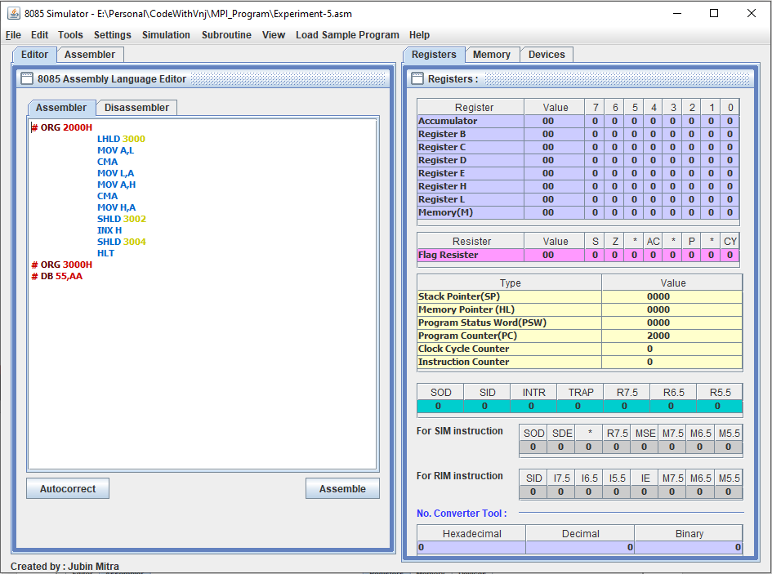

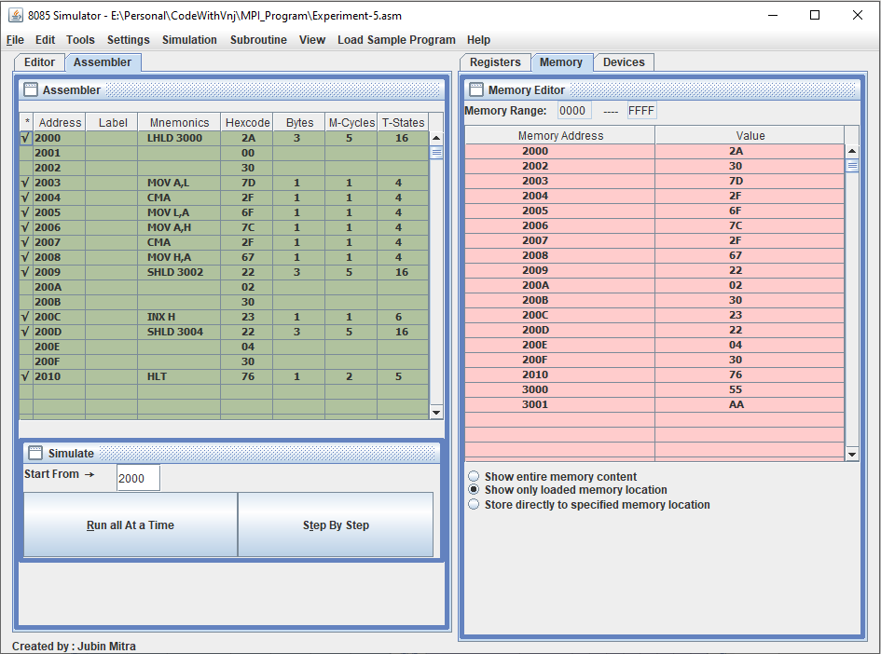

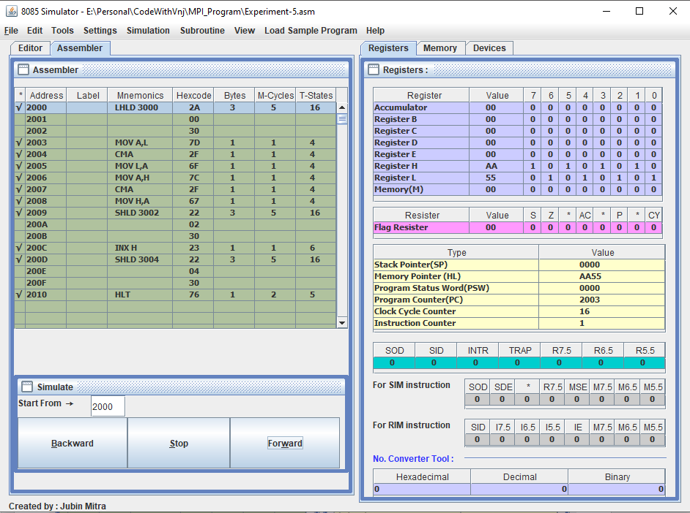

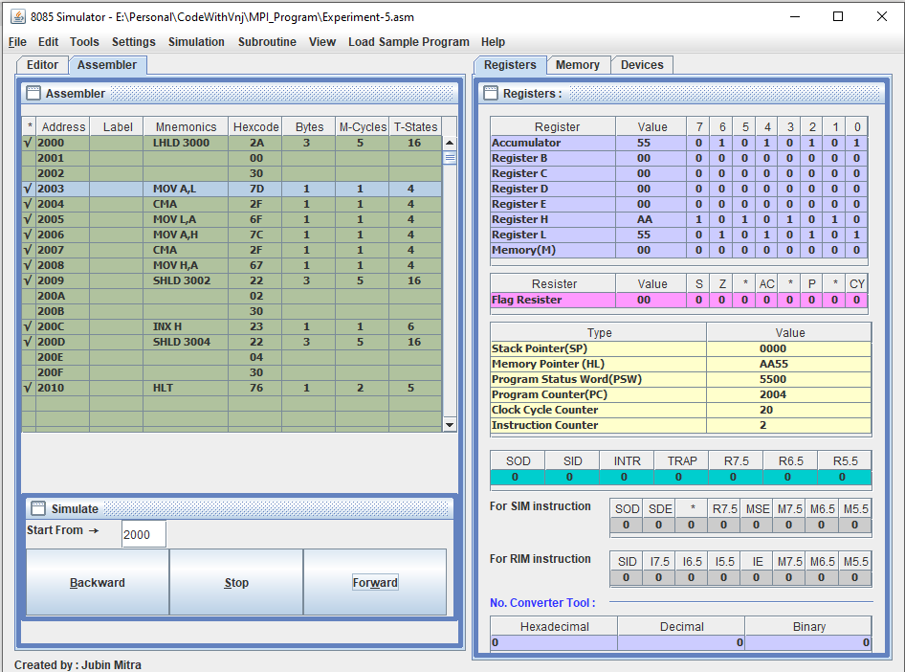

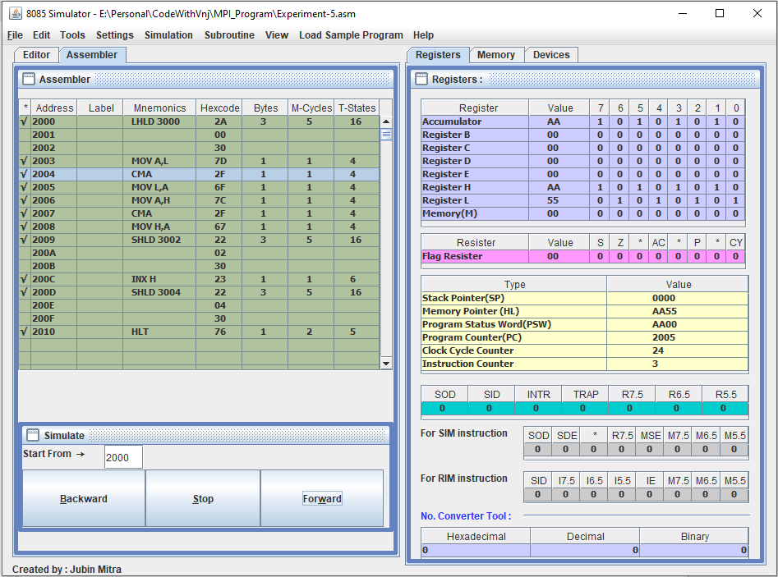

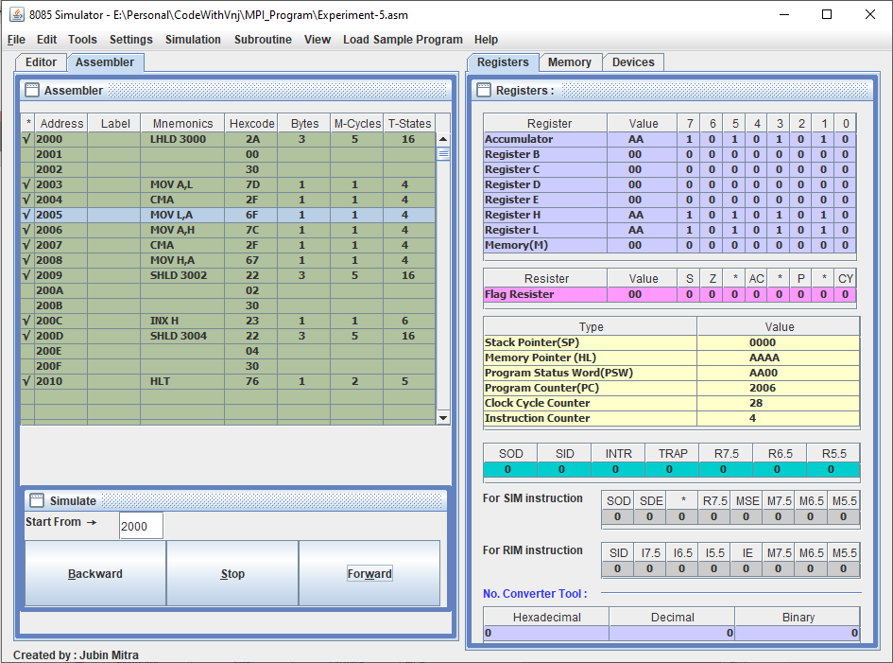

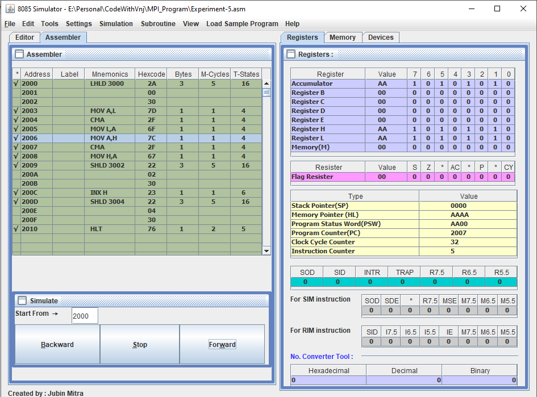

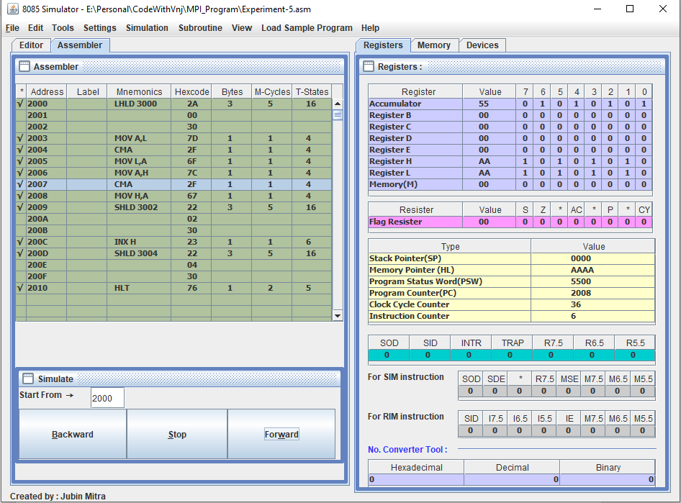

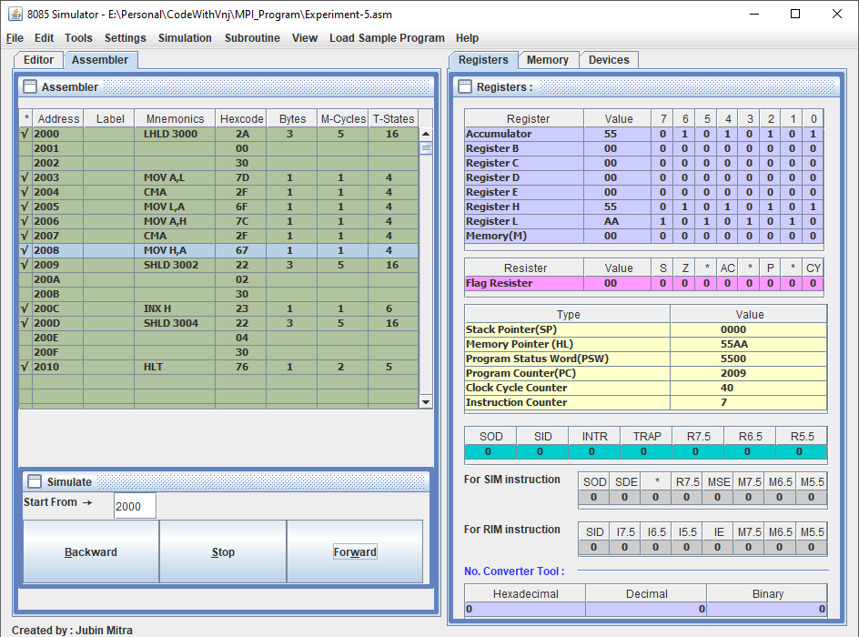

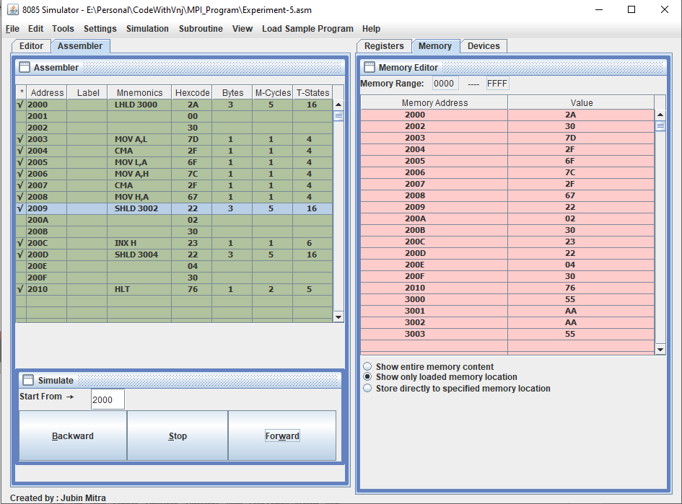

**2’s Complement:**

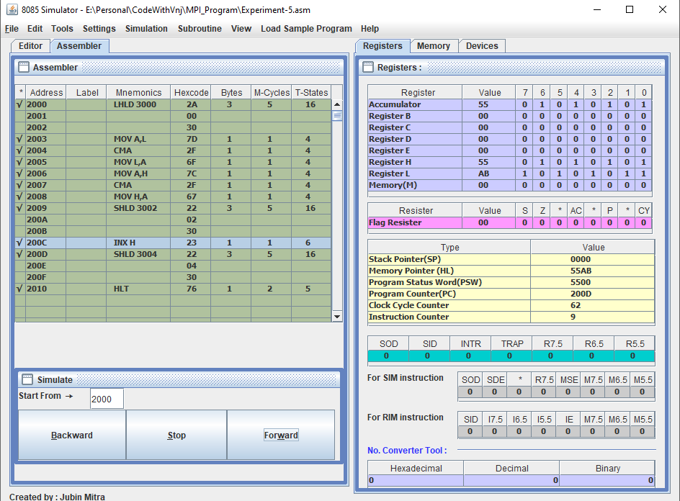

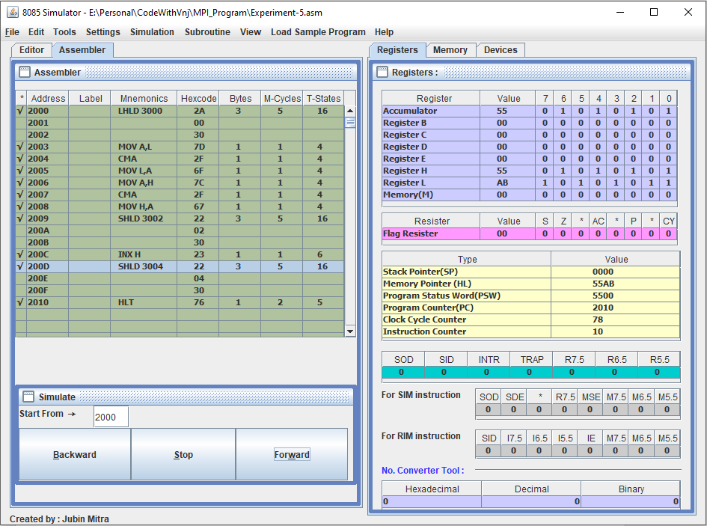

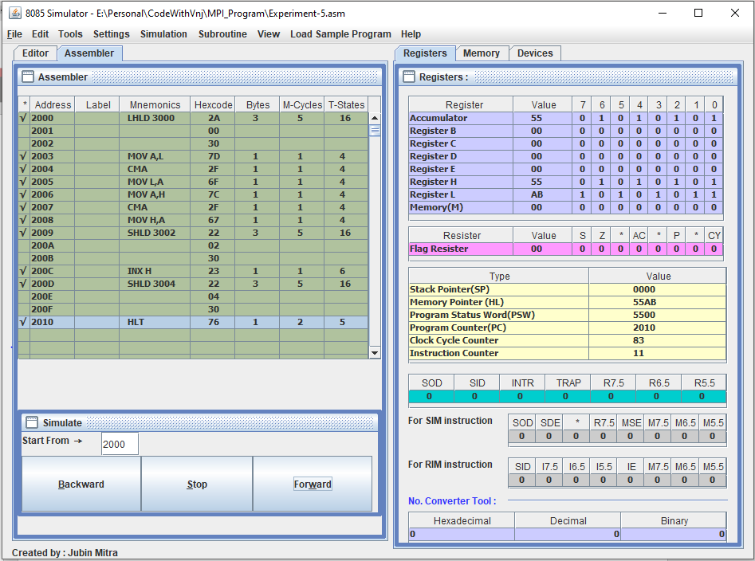

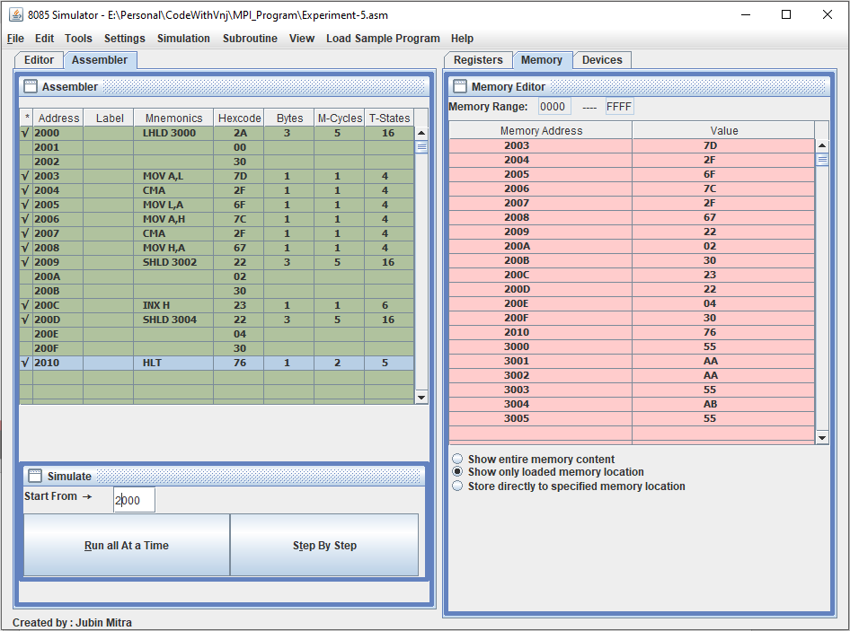

**Learning outcomes (What I have learnt):**

1. Learnt to find the 1’s complement of 16-bit number.
2. Learn to find the 2’s complement of 16-bit number.

**Evaluation Grid (To be created as per the SOP and Assessment guidelines by the faculty):**

|  |  |  |  |
| --- | --- | --- | --- |
| Sr. No. | Parameters | Marks Obtained | Maximum Marks |
| 1. |  |  |  |
| 2. |  |  |  |
| 3. |  |  |  |
|  |  |  |  |